HOW TO CHANGE YOUR PAYCOM USERNAME
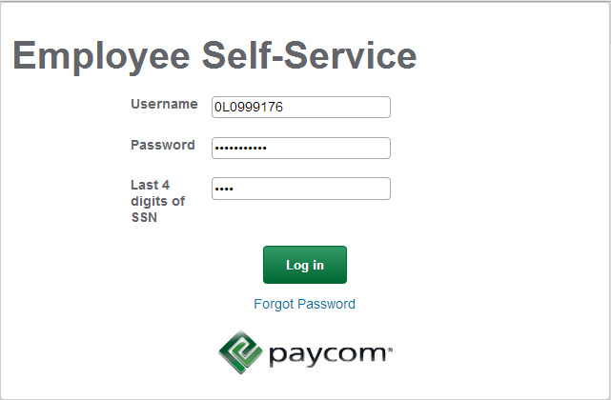
- Log into your Employee Self Service with your original log in credentials.

- Select “Change Password or Username” from under the “My Information” title.
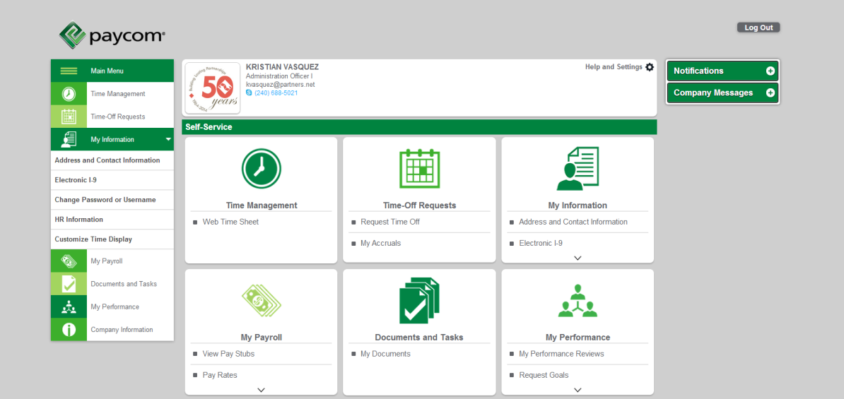

- Click on the green button “Change Username.”
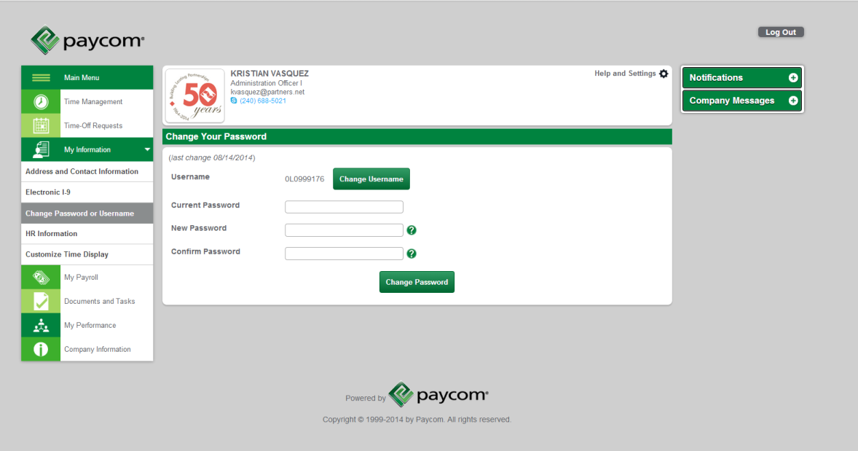

- Enter an email address that you would like to use as your username (This is the only option you have- customized usernames are not accepted).
Click the green, “Update Username” button.
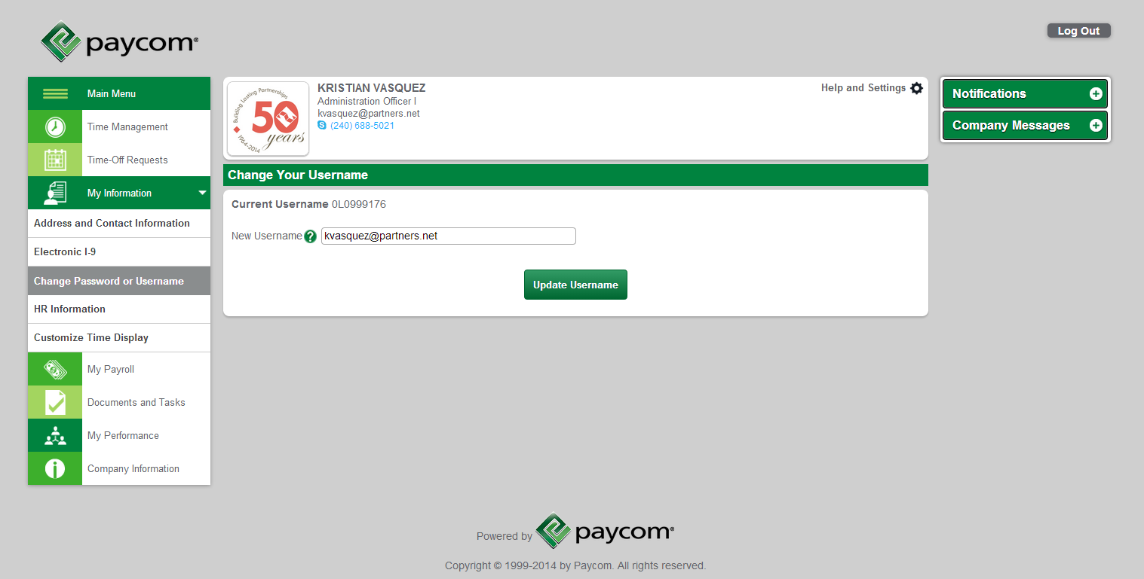

- Your page will refresh and your confirmation message (see below) will display.
